
The EYFS units for Understanding Christ were based on the six EYFS units of the Emmanuel Project On the flash drive, you will find detailed copies of the original units. In each, there is an encounter with a story from a different religion. The Emmanuel Project uses the units in the order below, which matches the seasons of the school year and Christian calendar well
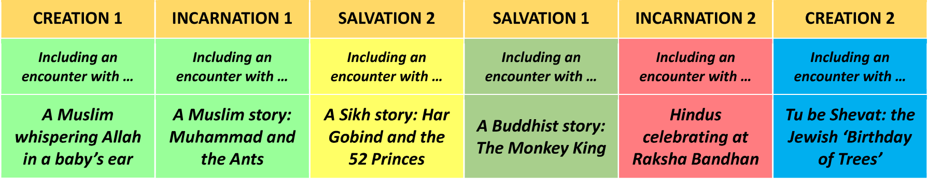

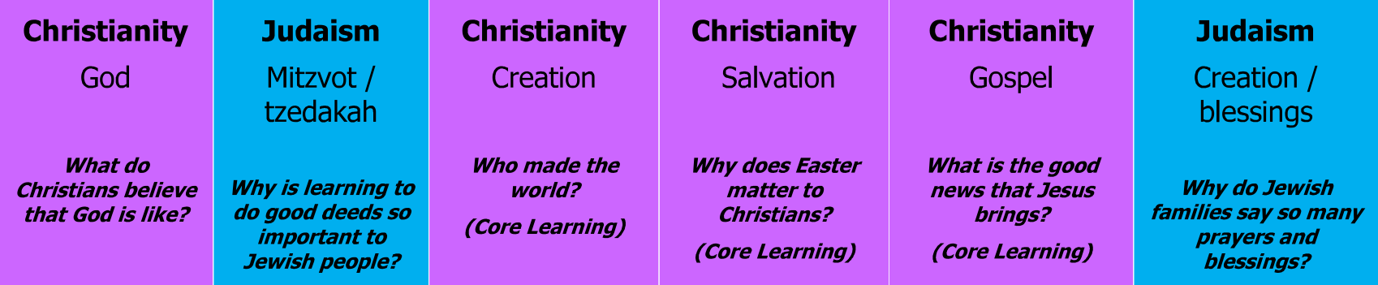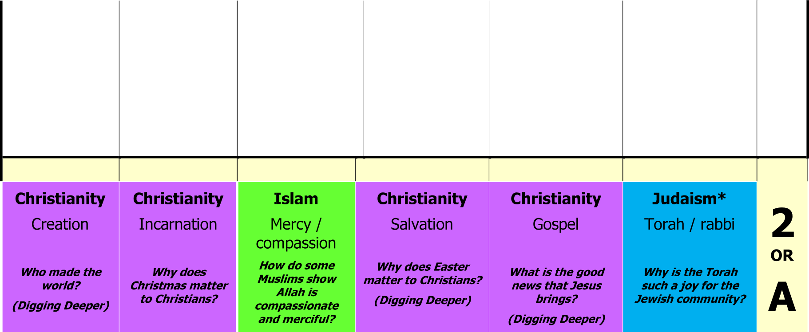
Autumn 1
Autumn 2
Spring 1
Spring 2
Summer 1
Summer 2

YEAR
Summer 2
Summer 1
Spring 2
Spring 1
Autumn 2
Autumn 1



YEAR


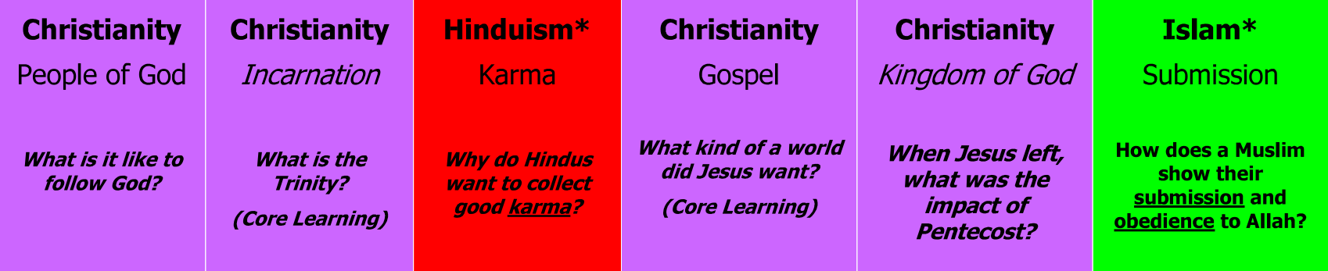
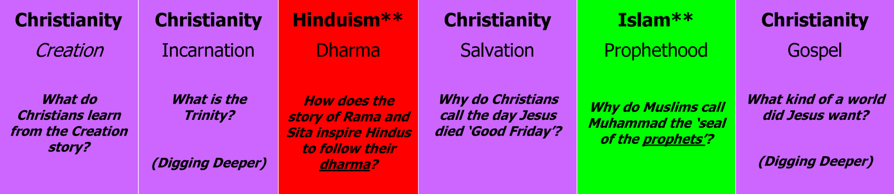



Autumn 1 | Autumn 2 | Spring 1 | Spring 2 | Summer 1 | Summer 2
 |  |  |  |  |  | YEAR
Autumn 1 | Autumn 2 | Spring 1 | Spring 2 | Summer 1 | Summer 2
 |  |  |  |  |  | YEAR




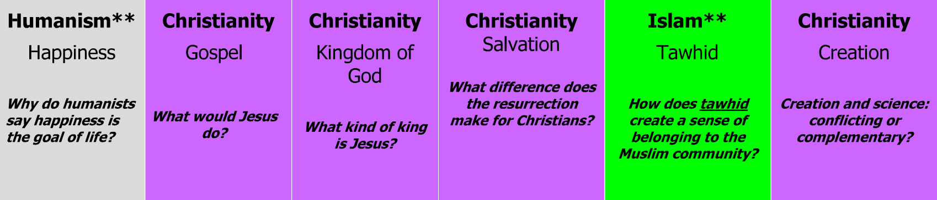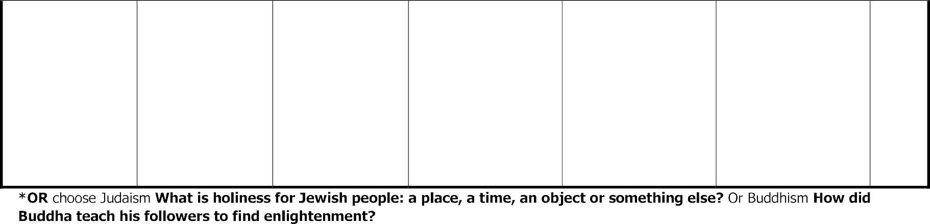
YEAR


Autumn 1 | Autumn 2 | Spring 1 | Spring 2 | Summer 1 | Summer 2
 |  |  |  |  |  | YEAR
Autumn 1 | Autumn 2 | Spring 1 | Spring 2 | Summer 1 | Summer 2

