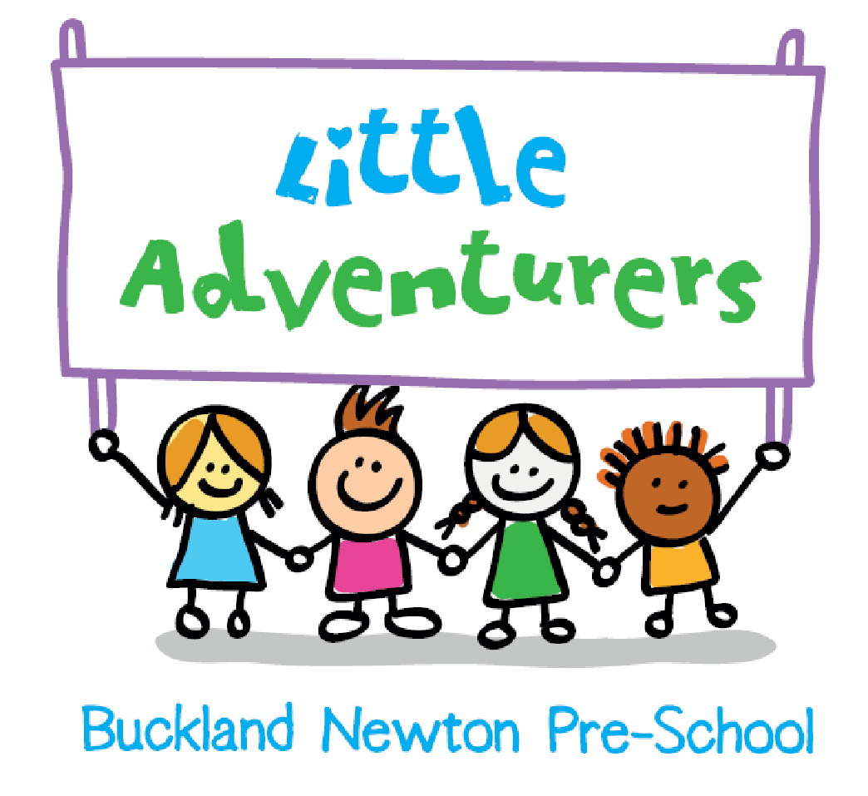

Spirituality Policy

Version Number | 2
Author of Policy | Phillip Sales (Headteacher)
Date Published | January 2025
Date for Review | January 2028
Signed and Date |   January 2025


This policy is underpinned by our school vision:

“ Let your Light Shine; on everyone, everywhere, everyday”

And our theological roots:

In the same way, let your light shine before others, that they may see your good deeds and glorify your Father in heaven (Matthew 5:16)

Buckland Newton CE Primary School, we use our school vision to channel our spirituality by:

Looking inward to help our light shine and looking outwards to help our light shine on others
Spirituality:
Enables us to become aware of God, one another, the world around us and ourselves. It enables and embraces children’s questions, doubts and wonder of existence.

Spiritual development:
Has to do with the universal search for individual identity – with our responses to challenging experiences, such as death, suffering, beauty and encounters with good and evil. It is to do with the search for meaning and purpose in life and for values by which to/we live.
It involves an increasing awareness of the concept of others. A growing sense of empathy, concern and compassion and an ability to reflect on how their values and principles affect their relationships with others.
Our aim is to: establish the right learning environment to enable the spiritual development of all pupils through the following objectives:

- Develop an appreciation of their uniqueness and value as a child made in the image of God;
- Develop an understanding of the distinctive ethos of this church school as well as the context, language and symbolism of the Christian faith;
- Develop knowledge and understanding of the school’s core Christian values and the Biblical teaching that underpins them;
- Develop an awareness of and respect for other people’s beliefs and faiths and the ability to articulate their own;
- Develop an appreciation of what it means to be a part of a community (e.g. using their gifts and abilities in the service of others);
- Develop strategies to build good mental health (see mental health policy);
- Foster self-awareness and encourage pupils to make informed decisions;
- Develop the skills and language required to enable them to reflect upon the big questions and mysteries of life;
- Begin to understand and make sense of their own feelings and emotions around certain encounters and events that occur in their life;
- Develop an awareness that experiences of disappointment, failure and loss may be occasions for spiritual growth;
- Understand the value of difference and diversity through involvement with others;
- Encourage curiosity, creativity and imagination;
- Develop the ability to reflect upon experiences of awe, compassion, beauty etc

- Develop a capacity to value the natural world, a sense of awe and wonder and a commitment to care for creation.

These objectives will enable the pupils to have a quality of life that encompasses respect, awareness, compassion, curiosity, understanding and relationships that reflect order, reason, balance and integrity within the context of Christian faith.

Teaching and learning
Through teaching and learning, the school pursues the aims and objectives by ensuring:

- The curriculum and all areas of our community life will be driven by the school’s Christian vision statement and associated values;
- Opportunities for spiritual development are actively planned into the curriculum and encouraged in all areas of school life;
- Unplanned and spontaneous spiritual opportunities for spiritual development are recognised, acknowledged and/or celebrated by staff and children;
- Collective worship celebrates the love of God for every individual and provides opportunities for children to respond and reflect on this;
- A solid understanding of the Christian concept of God as Father, Son and Holy Spirit; of prayer and of the Bible is nurtured and developed;
- The school building and outdoor environment provides appropriate spaces for silence, stillness and prayer;
- That children’s spiritual capacities such as imagination, empathy and insight are fostered through the creative arts and interactive multi-sensory teaching strategies making use of the outdoor environment and relevant educational visits;
- The provision of opportunities to listen attentively and observe carefully, listening with discernment, valuing what is good and worthwhile and making judgements through discussion and exchange of views and ideas;
- Support for learning to live with success and failure for themselves and with others;
- That the RE curriculum delivers knowledge and understanding of spirituality from a number of world faith and worldview perspectives;
- That children are given as many opportunities as possible to explore the wonder of the natural world and to develop an understanding of the Christian belief that creation is a gift from God to be enjoyed, cherished and protected;
- Promotion of strategies for positive mental health

Approaches
In our school we seek to find ways in which all areas of the curriculum can contribute to children’s spiritual development and to highlight opportunities for these in our planning

- Seeking to foster spiritual capacities, e.g. imagination, insight and empathy;
- Allowing children the security and opportunity to explore and express feelings and emotions and to celebrate diversity;
- Providing opportunities for prayer including silence and stillness;
- Sharing feelings and experiences that foster hope, joy, reassurance and encouragement;
- Encouraging children to develop relationships based on the school’s Christian vision and associated values;
- Enabling children to make the links between the Church and Biblical teachings, the life of the school and the wider community and how these impact on their own understanding of themselves and their place within the world today;
- Providing an environment that promotes space to reflect, think and wonder.

The document below shows how we link spirituality to all areas of school life:

Subject | How do we encourage spirituality across the curriculum
Maths | - Identifying pattern and creating awe and wonder regarding infinity  - Perseverance when tackling tricky tasks  - Sense of achievement- Doodle Learning  - Creating confident learners  - Teaching children self-worth and encouraging them to take risks when solving problems  - Identifying maths concepts such as time and space  - High level of challenge in all maths activities
Literacy/ reading | - Understanding the world and others feelings through books and texts Developing compassion and understanding of others  - Understanding emotions through written words  - Having aspirations through inspiration in books and text  - Visiting other worlds through books and text  - Creating an idea of awe and wonder through literature  - Perseverance when writing/reading  - Sense of achievement  - Creating confident learners through developing reading and class discussions  - Teaching children self-worth and encouraging them to take risks
Science | - Asking questions about science, religion and the world  - Creating awe and wonder about various scientific concepts  - Discovering space, the universe and beyond  - Creating links and questions between science and religion  - Perseverance
Computing | - Awe and wonder of what can be found on the internet  - Joy and excitement of what can be developed and created  - Communication with others and how to take responsibility for themselves online
PE | - Working as a team  - Caring, encouraging and supporting others  - Participating in sports teams to achieve a bigger goal  - Understanding failure and disappointment as well as success and joy  - How the body works - the wonder of human life  - Mindful moments in swimming whilst in the water
RE | - Developing a sense of questioning the world around them  - Asking questions about faith and religion on a personal and wider level  - Use of music and art  - Understanding other cultures, opinions, values and points of views  - Understanding many celebrations and beliefs  - Developing an understanding of commitment and sacrifice
Creative Learning (DT, ART, Geography, History, fine motor skills, learning through play, music) | - Discovery  - Understanding the beauty in design and the world  - Personal achievement  - Perseverance  - Communication and working with others  - Problem solving  - Historical figures- how they affect and help others  - Key figures (diversity)- Mother Teresa, Martin Luther King, Dalia Lama etc  - Understanding how subjects such as art can have an emotional impact on the beholder and the artist as they are making the art (impact of the activity on the artist)  - Understanding the world and the way people treat each other in subjects such as history and geography  - Perseverance  - Resilience  - Achievement  - Self-exploration and an understanding of you as an individual  - Understanding other cultures, opinions, values and points of views  - Understanding of diversity  - Questioning the world and the environment  - Looking at war and peace  - Moments of love overcoming hate (e.g WW1 football game)
Forest School and Outdoor Learning | - Nature  - Mindfulness  - Hugging and using trees for reflection  - Reflection Time  - Fire- how this is symbolic in our lives
Worship | - Big Questions  - Prayer  - Reflection  - Sharing Collective Worship  - Listening to stories  - Connecting together  - Sharing a multitude of emotions and feelings  - Empathy  - Awe and wonder  - Creating questions  - Encouraging self-exploration  - School values  - Wassail
Around the school | - READY, RESPECTFUL, SAFE  - Promoting self-responsibility for behaviour  - Caring for others inside school and on the playground  - Respect  - Kindness  - Thankfulness  - Manners  - Helpfulness  - Our School Values  - Beauty of nature  - Own community - village/ surroundings  - Neighbours and community relationships  - Sport Leaders/Leading Lights  - Prayer corners and reflection areas in school

Windows, Mirrors and Doors.
We use the ‘Window, Mirror, Door’ concept:


Windows: Opportunities to look out on the world to gaze and wonder: The Wow and Ows moments. The things we find amazing and bring us up short.
Encounter: Thinking about the beauty of our world


Mirrors: Giving opportunities for children to reflect, to look inward to consider some of the big questions of life: To explore their own insights and those of others.
Reflection: Thinking about myself

Doors: Giving opportunities to children to respond, to do something to go through the door of a creative expression of their own thoughts and convictions.
Transformation: The learning to live by putting into action what they believe and thinking of others


Candles: Thinking about things beyond what we can see and big questions and awe and wonder
Thinking: What is beyond what we can see?
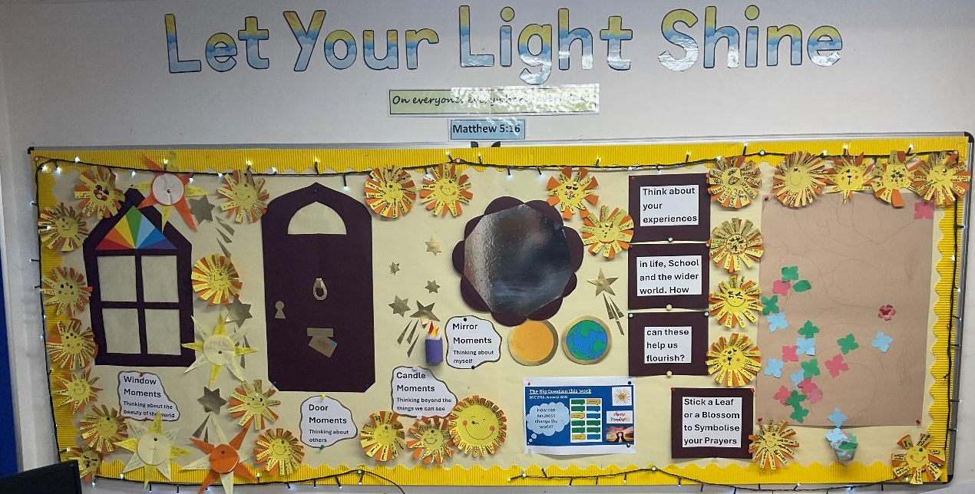

Pupils’ spiritual development is shown by their:
- beliefs, religious or otherwise, which inform their perspective on life and their interest in and respect for different people’s feelings and values
- sense of enjoyment and fascination in learning about themselves, others and the world around them, including the intangible
- use of imagination and creativity in their learning
- willingness to reflect on their experiences.
Monitoring and evaluation
Spiritual development cannot easily be measured and continues throughout our lives. However, opportunities offered to children for spiritual development will be monitored and evaluated in the following ways;

- Observing and listening to children;
- Regular discussion at staff and governor meetings alongside the school’s Christian vision and values;
- Sharing of classroom work and practice;
- Ensuring that staff have a clear understanding of what spirituality means in this school by providing them with induction and development training;
- Evidence from pupils’ work, e.g. reflective diaries, RE books, SMSC work, creative writing, art;
- Regular inclusion in the SEF;
- CPD opportunities and sharing examples of good practice with other schools.

