

Young Carer Policy
2025-26

Version Number | 1
Author of Policy | Phillip Sales (Headteacher)
Date Published | September 2025
Date for Review | September 2026
Signed and Date |   September 2025


Aims of young carer policy

To improve the progress and raise the standard of achievement for young carers To support young carers in improving their attendance
To ensure that young carers feel included and supported within their school community and that reasonable adjustments made to promote this
To improve the wellbeing and self-worth of young carers in the school community
To protect young carers from unjust treatment due to their caring role and improve co-ordination with other agencies and support services
To give young carers a voice in the school community and involve them in decisions affecting young carer provision
To ensure that staff recognise flexibility may be needed when responding to the needs of young carers
To have accountable professionals to monitor young carer provision and support

Definition of a young carer

Young carers are children under the age of 18 who help to look after someone in their home or another family member. This could be a sibling, parent, both parents or a grandparent who has a disability, illness, mental health condition or who misuses substances.
Buckland Newton Primary’s definition of a young carer is a child, under the age of 18, who is either the main carer, shares a caring responsibility for, or whose day-to-day life is impacted by someone in their home. Our definition also includes young adult carers (18 to 25 years old) who may operate within our sixth form.
Having a clear definition of the role of a young carer is important, but unfortunately, many will remain hidden from view due to stigma they may feel. To help identify and support those hidden young carers, it is vital that professionals are equipped with the understanding and knowledge to detect potential signs that a young person may have a caring responsibility.

Safeguarding
Buckland Newton Primary actively promotes the welfare and wellbeing of all pupils. Where appropriate, the school will refer a young carer to the local authority for a referral with permission of the parents/carers. The school will follow the school’s safeguarding policy regarding any young carer at risk of significant harm due to inappropriate levels of caring.

Policy Principle
Buckland Newton Primary acknowledge, recognise and value the caring responsibilities that pupils in our community have. As a school, we strive to raise the awareness of these young carers amongst staff and pupils, to provide effective support for our young carers and remove any barriers which could potentially inhibit their academic, social and personal development.

“People don’t realise that we don’t have a choice.” – BCP young carer, March 2023.
We want young carers in our school to feel seen, feel heard and feel supported. By engaging with the Level Up Programme, we hope to improve the support in place for young carers which in the long-term, will have a positive impact on young carer’s academic performance, attendance and aspirations. This policy outlines the whole school approaches and strategies that will enable young carers at Buckland Newton Primary to flourish.

“The session was the most living CPD I’ve ever experienced - I feel totally moved, inspired and determined
to be part of the solution.” – Dorset secondary school pastoral worker, November 2022.
At Buckland Newton Primary we have high expectations of all pupils, and we believe all pupils should have equal opportunities. However, every child needs to feel safe, supported and understood to achieve self- actualisation. National statistics suggest that young carers do not always feel this way in school. A survey conducted by the Carer’s Trust (2023) highlighted that over 42% of young carers ‘always’ or ‘usually’ feel stressed and 52% said they do ‘not often’ or ‘never’ get help from school or college to balance their work. We recognise that such caring responsibilities can, and will, have an impact on a child’s social and emotional wellbeing and their academic performance. Therefore, we are committed to improving provision and support at Buckland Newton Primary to enable young carers fulfil their potential.
MYTIME Young Carer’s data collected in March 2023 shows that after engagement with the Level Up Programme, over 85% of young carers had someone trusted to speak to, over 80% of young carers had a regular opportunity to meet other young carers and that they felt more positively about how their peers and school staff thought about and recognised young carers.

"I like going to young carers groups as I listen to other people’s stories, and it makes me realise I'm not the
only one going through it. It makes me feel less lonely." – Dorset primary young carer, March 2023.
By working closely with MYTIME Young Carers, Buckland Newton Primary will ensure that all stakeholders have a greater understanding of who young carers are, the challenges they face and how they will be supported. The whole school and classroom strategies are outlined in this policy, staff and students will be exposed to training and sessions to raise awareness. We will use the voices of the young carers in our school to shape the support available.

(1)Carers’ Trust (2023) Being a young carer is not a choice. It’s just what we do.

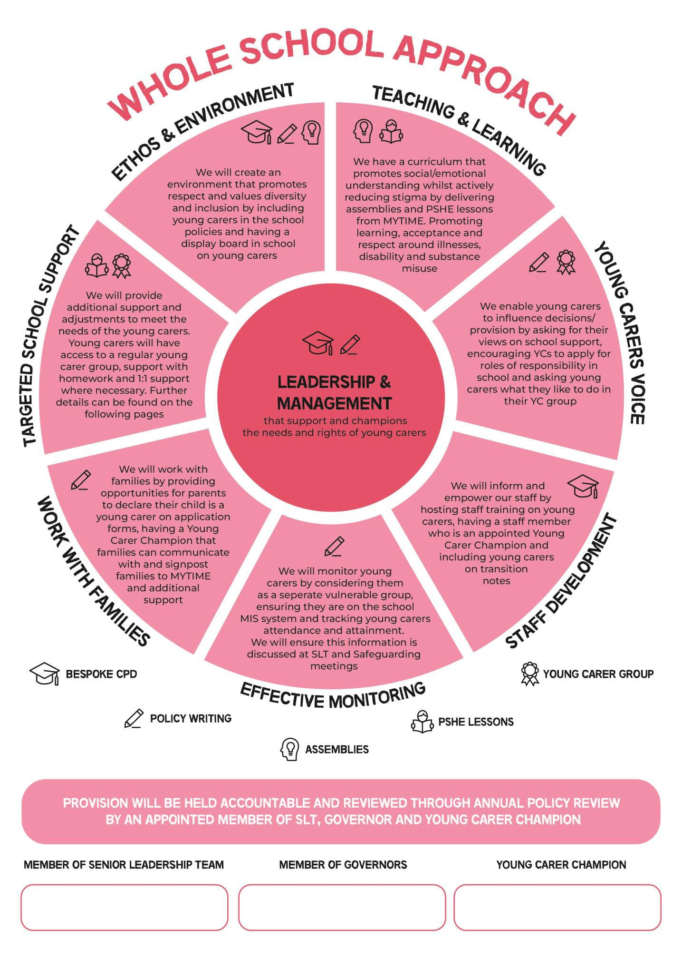
Mrs Angela Jesty
Mrs Caron White (SEN Gov)
Mr Phillip Sales (Head)

Roles and responsibilities

Appointed Governor
Understand how policies and procedures support young carers
Explore what training and development has been provided to the Champion and staff
Know what information is shared with parents and externals on the support of young carers Hold senior leadership and Champion to the aims and objectives of the school’s young carer action plan

Appointed member of Senior Leadership
Support YC Champion with implementing the action plan and strategy for young carers Support YC Champion with organising the delivery of the Level Up Programme and subsequent MYTIME offers
Have overall responsibility for the provision and progress of young carers Provide data for the YC Champion and MYTIME at required points in the year

Young Carer Champion
Oversee the policy and provision for proactive identification of young carers
Establish a first point of contact for young carers and their families, ensuring they understand how to self-identify and access support
Ensure staff have a good understanding of who young carers are and the support available in school
Ensure YCs are known and identifiable by all staff
Ensure YC numbers are continuously reviewed, and this information is included in the school census
Ensure YCs are supported appropriately by communicating with the young carer, their family and their teachers
Ensure the curriculum promotes a full understanding of the role young carers play in their home, whilst actively reducing stigma
Provide opportunities for 1:1 support and YC groups, building a community of young carers
Create a clear line of communication for young carers to access support
Report of the strengths, weaknesses, and recommendations to SLT to improve support for young carers
Create annual action plans for young carer provision, with the support of MYTIME Identify barriers to achievement, through conversations and data monitoring, and build provision to combat these
Keep up to date with local and national developments Oversee transition between phases of education
To communicate with MYTIME to support them in the development of the Level Up programme, with the goal to build strong young carer provision across Dorset

Buckland’s support and adjustments for
young carers

There is a dedicated Young Carer Champion (Angela Jesty) who supports young carers. Young carers can speak to the champion at School

If a young carer has incorrect or missing uniform, we will:
- Provide them with access to spare uniform discreetly
If a young carer is falling behind their peers academically, we will:
- Put reading and / or maths interventions in place

If the person a young carer cares for is
critically unwell, we will:
- Inform staff working with that YC of the situation
- Provide opportunities for the young carer to communicate with that person from the office phone.
If a young carer is struggling with attendance, we will:
- Have open conversations with families around barriers to attendance/ punctuality
- Put in support to overcome the barriers discussed. For example, access to the car park for drop-off.

If a young carer is struggling to complete their homework we will:
- Provide opportunities for the young carer to complete homework at school during homework club on a Friday.
- Amend homework expectations, as appropriate

All staff will know who the young carers they work with are by:

- Including YCs on class information packs

To support young carers with their mental health, we will:

- Provide a time out/ reflection card, as appropriate
- Include mindful activities in young carer groups
To allow a young carer to connect with other young carers, we will:
- Run a regular YC group at school
- Bring young carers on a MYTIME school event
- Share information about MYTIME Zoom Youth Group and Making Memories holiday events

